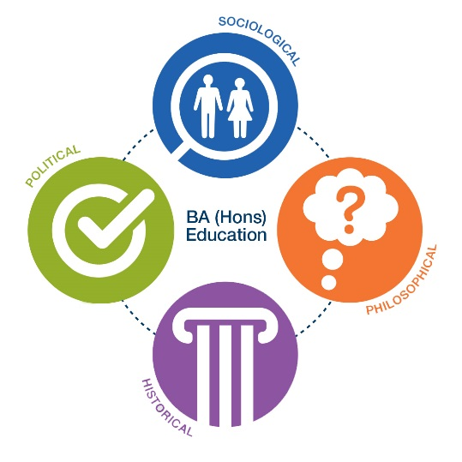
BA (Hons) Education
Induction Week Timetable
Stage 3

Date | BA (Hons) Education sessions
Wednesday 20th September  ONLINE | - Start online Canvas induction  - Independent Study: Levin, P. (2011) Excellent Dissertations, Ebook (also available in library). Recommended chapters are: 4, 5,6,11
Thursday 21st September  Room: BSTC 1.48 | 10.00 – 11.30  11.30 – 12:00  12:00 – 12:30 | Welcome Back; Degree Classification weighting; Time management; Avoiding plagiarism Talk.  Introduction to the dissertation - group work task  Coffee and Refreshments  Wellbeing Talk (BSTC G.33)
Friday 22nd September | Complete Canvas induction and independent study

